**CS 210 project  
Grocery-tracking program**

**Chase rush**

**10/14/2023**

**Program Overview**

The Grocery-tracking program is implemented in C++ and has the following functionality

**Menu option one:**

Allows the user to make a input on one item and retrieve its frequency of appearance in the current store

**Menu option two:**

Prints a list of items and there frequency of appearance and reads data from our input file in this case being CS210_Project_Three_Input_file.txt

**Menu option three:**

This prints a histogram of the repeated items and the frequency using asterisks

**Menu option four:**

This will exit the program and max a save to backup the files data

Screenshot!...P.S. I even added code to show if we were unable to read the input file as you see at the top. The program will still run without the file as seen further but this wasn’t intended.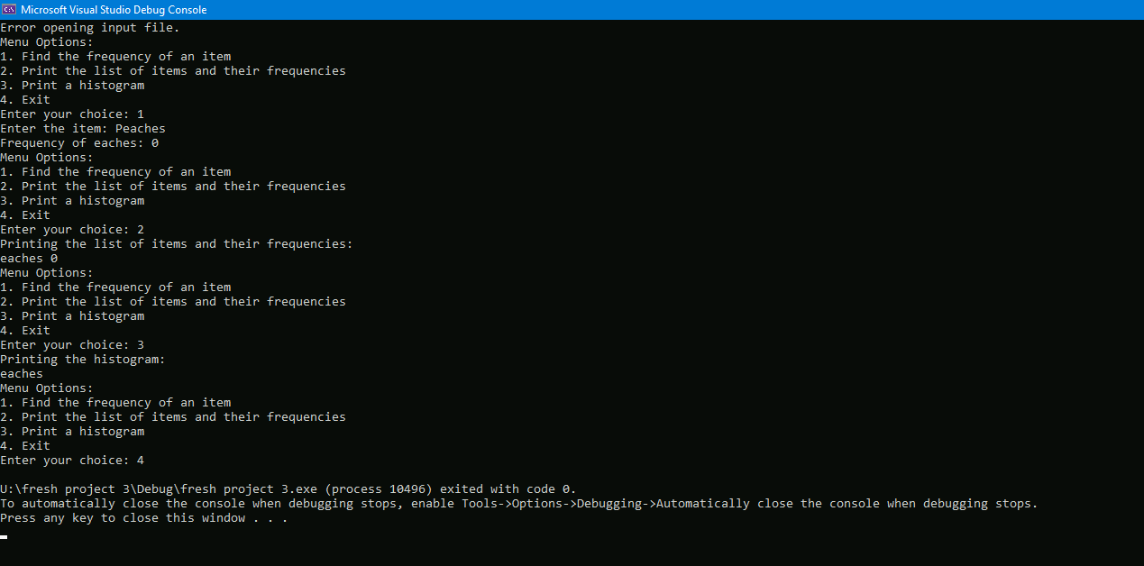

**Code Design**

This program is designed with a class called ItemTracker this encapsulates the functionality to reads,track and further analyze items.

Class:ItemTracker

Privatedata  
items: this is a map to store the items and their frequencies

Methods:

Readinputfile:this read and process our input file

Findfrequency:returns the frequency of a specified item

Printlist: this helps us get a list of the items and there frequency

printHistogram: Prints our histogram of the items frequencies with using asterisks

saveDataToFile:this saves our backup file

**User interaction**  
this program is meant to be looped intel the user decided to further exit via menu option 4.